Chapter 11, Solution 77.

The wattmeter measures the power absorbed by the parallel combination of 0.1 F and 150 .
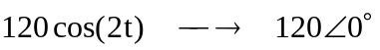, 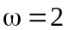
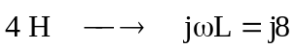
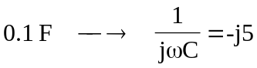

Consider the following circuit.
j8 
Z
6 
1200 V
+
−
I

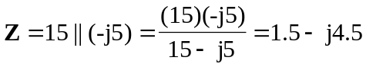

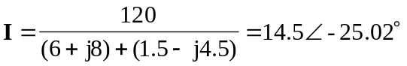

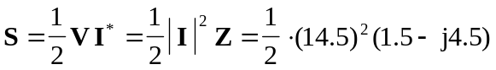
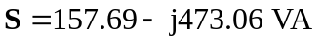

The wattmeter reads
